Laser Bears
  - Game Design Document

Sander Theeuwen
PC, PEGI 7
Contents
Gameplay 3
Unique Selling Points 3
Game Flow 3
Controls 6
Platform 7
Main Gameplay Concepts 7
Genre 7
Setting 7
Game World 7
Mood 7
Theme 8
Mechanics 8
Dynamics 8
Aesthetics 8
Similar Products 8
Inspiration 8
Literature List 8

Gameplay
In Laser Bears, the player explores a town, one district at a time, where every district has buildings, and every building has floors. Every floor must be powered by colored lasers.
The player does this by collecting mirrors in the ruins of the floor and placing them so the laser(s) shine to the receivers that power the floor.

Unique Selling Points
- Adaptive progressive music.
- Unique mirror / light puzzles.
- Simple controls

Story

Prologue
A happy colony of space bears is living peacefully on a small planet. These bears and their buildings are powered by lasers that come from the generator district. The colony is colorful and happy, as seen in Figure 1.
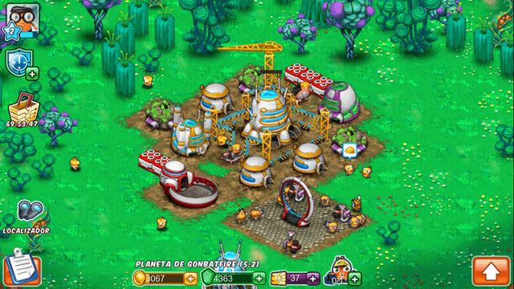
Figure 1 Galaxy Life, inspiration for color scheme (Gonbatfire, 2019)
Suddenly a meteor shower hits the colony causing the buildings to get damaged, the generator district among them, resulting in the lasers powering down. Without energy, the buildings quickly lose power, the residents among them.
The once lively districts now turned dormant ruins, showing no signs of life. Many years pass, turning the colorful buildings into ruins covered in gray dust.
One day, a single meteor strikes the generator district again, but this happens to turn on one of the lasers, which is pointing at one of the bears. With the energy of the laser beam, the bear turns on, awakening to the ruins of the colony, determined to restore the town. The player guides this lonely bear throughout its journey. This is like the start of Sheepy: A Short Adventure (Carrot Helper - 100% Walkthroughs, No Commentary, 2024).

Main Game
As the player powers up the first building, a generator, the building regains power. Generators start working again, residents start to awaken. While the building reboots, the other buildings are not functional yet, as the debris from the meteor shower still covers the lasers, preventing automatic restoration. The awakened residents will focus on making sure the building is operational and stays powered, which is why the player must restore power to the other buildings alone. When the full district is powered, the bear that the player controls will be able to go to adjacent districts, as the bear now feels safe enough to explore the surrounding area.

Music
Music will be added to the game using Fmod.

Prologue
The game starts with happy peaceful music, rich in instruments and melody, a lively mood to signal the happiness and peace of the colony. When the meteors hit, the music becomes action packed for a moment, eventually turning into silence as the buildings and the residents power off. The silence matches the deep slumber off the colony.
As the laser beam hits the bear, music starts again. Soft, simple, hopeful, conveying both the life of the awakened bear as well as the solitude it finds itself in.

Colony
The whole planet has similar features, a simple drone, the same tempo, time signature and key. As this base is expanded a lot and in different variations, this base is very simplistic.

Districts
Every district has its own theme, where the space between districts is used for transitions. The more buildings the player powers, the more layers the district’s theme gains.

Buildings
Buildings consist of several floors, between 3 and 5. When entering a building, the district’s theme plays softly in the background but starts out empty. As the player powers a floor, the music gains another layer. These layers disappear once the player leaves the building. Once a building is fully powered, an element of the building’s music will remain in the district’s theme (for example soft chimes).

Floors
Every time the player powers a receiver on the floor, a triad is played, indicating the progression of the player, based on the music event from hitting an enemy in The Legend of Zelda: Wind Waker (leapinglarry86, 2023).

Game Flow
The game flow is based on a model seen in Figure 2, having the following components:
Action: What does the player do?
Reward: What does the player get for performing the action?
Expansion: What can the player do with the reward?
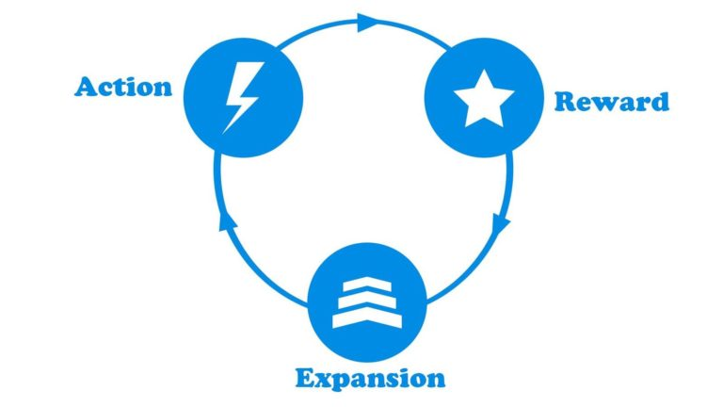
Figure 2 Core loop components (Fox, 2023)

Primary Game Loop (1st half)
Action:
The player searches the ruined floor.
Reward:
The player receives mirrors that belong to the floor.
Expansion:
The player can power the floor with the mirrors.

Primary game loop (2nd half)
Actions:
The player places mirrors to redirect the laser beam(s) towards the receiver(s).
Reward:
The receivers are powered; part of the floor regains power.
Expansion:
The floor regaining power unlocks the door to the next floor.
When the building is fully powered, its residents are reawakened.
When the district is fully powered, the player can venture to adjacent districts.

Controls
To keep the controls simple, the game can be played using only the cursor. However, in some situations, the player can use certain inputs to allow for more efficient control.

Camera Points

Districts
Top-down locked view focused on the player.

Floors
The search section is done in first-person.
The puzzle section is done in top-down locked view, focused on the middle of the area. The area gets a grid-like form to help with accuracy of placing mirrors. The puzzle happens beneath the floor.
After completion, the camera remains top-down locker but focused on the player.

PC

Districts
Click and the bear will move to the clicked location via pathfinding.
The arrow keys and WASD will move the bear directly.

Floors
In the search section, the player points and clicks on the mirrors to collect them.
In the puzzle section, the player can drag and drop the mirrors to the desired location, they can also click to select a mirror and click to place it at the location. Alternatively, the player can use the number keys to select a mirror type and then click on the location.
To rotate a mirror, the player can click arrows next to the mirror or press Q or E to rotate the selected mirror. To remove a mirror, the player can drag and drop it off the map or an unavailable space, back into the menu, or press the “remove” button while having the mirror selected.
After the puzzle section is done, the player can explore like in a district by clicking at a location or using the arrow / WASD keys.

Platform
The game will be developed for PC, for versatility and fast development and testing.

Main Gameplay Concepts

Genre
The game alternates between exploration in the districts and buildings, and the puzzle elements from the lasers.

Setting
Laser Bears takes place in space, a planet with gray ruins that regain color as the player progresses and powers up buildings. Districts are spread out, with a clear indication where the district ends and a new one begins. Buildings are placed closer together while still allowing the player to explore. The buildings are separated into several floors, each having a door with a staircase. The environment is filled with debris from the damage, though gets cleaned up over time when as the player progresses.

Game World
The player is limited in their exploration based on the power of the district. Once a district is powered, the player is allowed access to adjacent districts. The player cannot leave the colony due to the same power constraint.
Mirrors are to be used on the floor they are found on only by the shape / color of the pedestal they stand on. This prevents the player from using mirrors for different puzzles.
Inside a building, the player is limited to the floors they solved and one they are exploring / solving to prevent skipping puzzles.

Mood
The mood can be summarized as “calm” and energizing the further the player gets, heavily influenced by the music design. At the start of a district / building, the player must feel alone and have the feeling their surroundings are asleep. The further the player gets, the more alive the environment feels. This is done by powering the residents of the buildings, the buildings regaining color as they regain power, and the music.

Theme
The game’s theme is hope. Starting from nothing, the player revitalizes the buildings one by one, rebuilding the town like before the meteor shower.

Mechanics
- Moving through the district.
- Moving between floors.
- Moving on the floor.
- Collecting mirrors.
- Placing mirrors.
- Rotating mirrors.
- Removing mirrors.

Dynamics
- Trial and error iteration.
Interacting with mirrors, seeing the solution fail or succeed.
- Imaginary ray tracing.
Thinking where the laser goes before placing a mirror.
- Symmetry.
Seeking solutions that look visually pleasing due to symmetry.
- Optimization.
Players challenge themselves to find the most efficient solution or try to save mirrors.
- Edge case testing.
Testing things that do not progress the game out of a curiosity standpoint, for example reflecting a laser backwards into the emitter.
- Self-designed challenges.
Players challenging themselves by playing in a more difficult way:
- Least mirrors possible.
- Placing the ‘first’ mirror last to test their imaginary ray tracing capabilities.

Aesthetics
- Calm mood.
- Lonely music that regains life through layers.
- Gray color scheme that turns more colorful.

Similar Products
Puzzle minigames from Spyro: The Eternal Night, as seen in Figure 3:
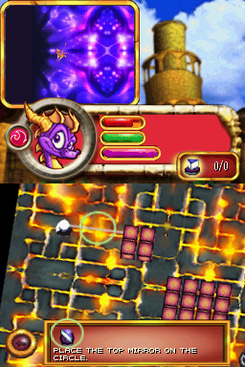
Figure 3 Spyro The Eternal Night (Auchampach, n.d.)

Inspiration
Puzzle base from Spyro The Eternal Night (Figure 3).
Buildings and atmosphere from Galaxy Life (Figure 1).
Music layering from Primavera (LudovicoLove, 2009).

Literature List
Auchampach, D. (n.d.). The Legend of Spyro: The Eternal Night (DS). Vizzed. Retrieved December 19, 2025, from https://www.vizzed.com/games/legend-of-spyro-thethe-eternal-night-ds-ds-71184-game
Carrot Helper - 100% Walkthroughs, No Commentary. (2024, February 11). Sheepy: A Short Adventure - full game walkthrough (No commentary) - 100% achievements [Video]. YouTube. Retrieved December 19, 2025, from https://www.youtube.com/watch?v=4jO63taxPpA
Fox, S. (2023, October 25). Mastering the art of game design: understanding and crafting the core loop. Space Gnome Studio. Retrieved December 19, 2025, from https://spacegnomestudio.com/mastering-the-art-of-game-design-understanding-and-crafting-the-core-loop/
Gonbatfire. (2019, March 26). Galaxy Life is back! And we need your help! Reddit. Retrieved December 19, 2025, from https://www.reddit.com/r/gaming/comments/b5j9ux/galaxy_life_is_back_and_we_need_your_help
leapinglarry86. (2023, April 15). Toon Link Combat is Undeniably Fun. Youtube. Retrieved December 19, 2025, from https://www.youtube.com/shorts/InHFlGiHPPE
LudovicoLove. (2009, June 8). Ludovico Einaudi - Primavera [Video]. YouTube. Retrieved December 19, 2025, from https://www.youtube.com/watch?v=qYEooPeyz5M

